**What is finance?**

* Finance is about how people, businesses, and governments manage money over time.
* It focuses on how to allocate limited resources (like money, wisely and efficiently).
* Every financial decision (like investing, borrowing, or saving) has costs and benefits that are:

+ Not occur at the same time

+ Often uncertain or unpredictable

* Finance uses economic tools to help make smart money decisions when future outcomes aren't guaranteed.

|  |
| --- |
| * It provides a framework to answer:  + Where should we get money?  + What should we do with it once we have it? |

**Main areas of finance**

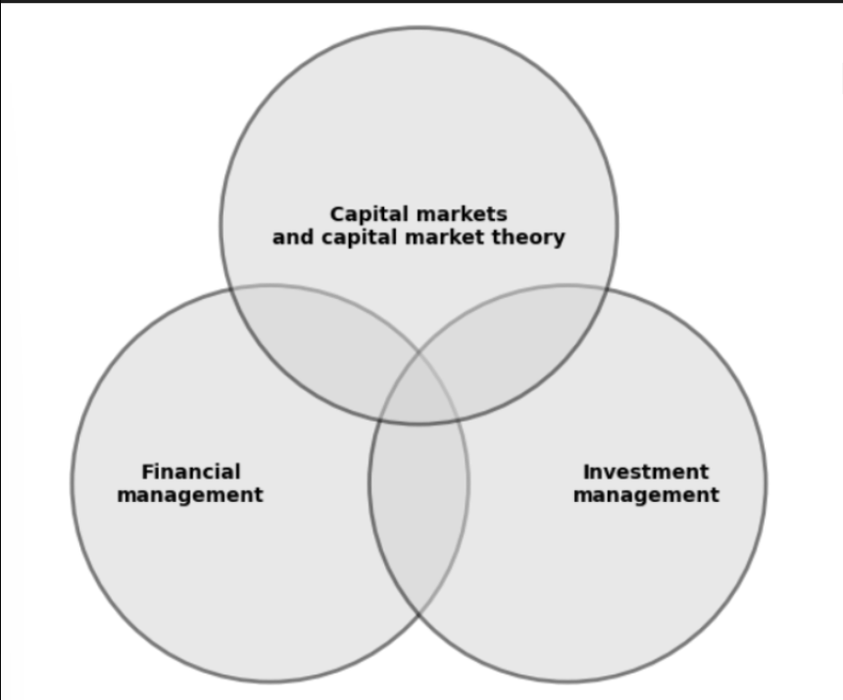

1. **Capital Markets and Capital Market theory** (Thị trường vốn)

* Focuses on how the **financial system** works: **Interest rates, Pricing of risky assets (like stocks, bonds, etc.)**
* **Financial system:**

+ Make financial agreement

+ Exchange assets

+ Manage risk

* It includes 3 main parts:

+ Financial markets (like stock exchanges)

+ Financial intermediaries (like banks, insurance companies)

+ Financial regulators (like central banks and watchdog agencies)

*Watchdog agencies: Ủy ban chứng khoán

|  |
| --- |
| Value of any financial assets = present value of expected cash flow |

+ Estimating the expected cash flows

+ Decide what interest rates to use for discounting

+ Caculate the present value of those cash flows

1. **Financial management** (quản lí tài chính doanh nghiệp)

* Focuses on two main types of decisions within a company:
* **Investment decision:** How to use funds? (buying, holding, selling assets, etc.)
* **Financial decisions:** How to obtain capital for long-term investments and daily operations (huy động vốn)

+ Internal / External funding (lợi nhuận giữ lại / vay nợ, phát hành cổ phiếu)

+ Make dividend policy choice (chính sách cổ tức)

+ Manage risk management

1. **Investments**

* Def: Commitment of money or other resources, hoping to gain benefits in the future
* Focuses on how individuals or institutions manage their funds wisely
* Risk – return Trade – off (cán cân giữa rủi ro và lợi nhuận)

+ Higher potential returns usually come with ***greater risk***

+ Safe investments tend to offer lower returns

* Efficient Pricing of financial assets (định giá hiệu quả)

+ In well-functioning markets, most assets are fairly priced.

+ It’s rare to find obviously underpriced assets.

* Overlapping Areas
* A **corporate finance manager** needs to understand **capital markets** to make sound financing decisions.
* An **investment manager** relies on **capital market theory** to evaluate and price assets.
* Both may use the same financial tools, principles, and market knowledge to guide decision-making.
* Each pillar has its role, but together they support each other in making effective financial decisions.

**Financial Market**

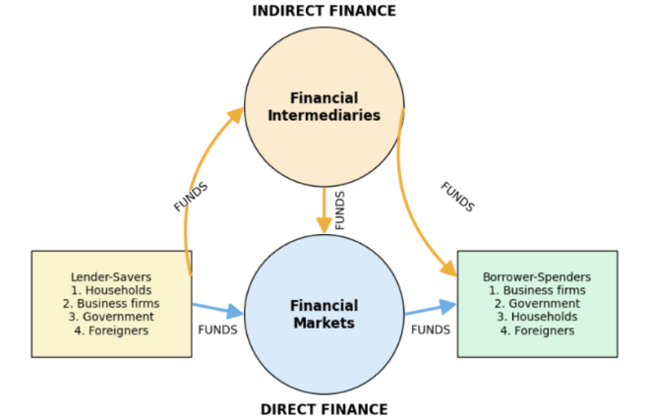

* Perform the essential economic function of:

+ Channeling funds from **savers** (households, firms, and governments) that have saved surplus funds by spending less than their income.

+ To **spenders** who have a shortage of funds because they wish to spend more than their income.

**Financial Market Classification**

|  |
| --- |
| **CLASSIFICATION BY NATURE OF CLAIM:** (Theo bản chất khoản vay / Quyền sở hữu) |
| * Debt market (Giao dịch trái phiếu, tín phiếu – người mua cho vay và nhận lãi.) |
| * Equity market (Giao dịch cổ phiếu – người mua trở thành chủ sở hữu doanh nghiệp.) |
| **CLASSIFICATION BY MATURITY OF CLAIM:** (Theo kỳ hạn) |
| * Money market (Ngắn hạn (<1 năm), ít rủi ro (ví dụ: tín phiếu kho bạc)) |
| * Capital market (Dài hạn (>1 năm), bao gồm cổ phiếu và trái phiếu dài hạn) |
| **CLASSIFICATION BY SEASONING OF CLAIM:** |
| * Primary market (Phát hành lần đầu (IPO), tiền về trực tiếp cho tổ chức phát hành) |
| * Secondary market (Mua bán lại sau phát hành (ví dụ: chứng khoán niêm yết trên sàn), tạo tính thanh khoản) |
| **CLASSIFICATION BY IMMEDIATE DELIVERY OR FUTURE DELIVERY:** |
| * Cash or spot market (Mua bán và giao dịch ngay lập tức) |
| * Derivative market (Hợp đồng tương lai, quyền chọn (giá dựa trên tài sản cơ sở) |
| **CLASSIFICATION BY ORGANIZATIONAL STRUCTURE:** |
| * Auction market (Giao dịch tập trung (ví dụ: sàn chứng khoán)) |
| * Over-the-counter market (Giao dịch phi tập trung (ví dụ: trái phiếu doanh nghiệp) |
| * Intermediated market (Ngân hàng đóng vai trò trung gian (ví dụ: tiền gửi và cho vay) |

**Financial Assets**

* **Assets:** Any resource that is expected to provide future benefits and, hence, has economic value.

+ Tangible assets  
+ Intangible assets

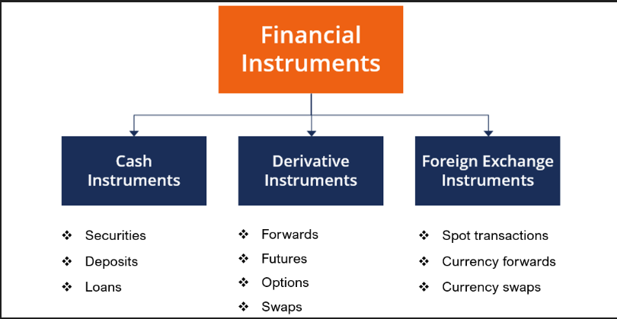

* **Financial assets (financial instrument):**

**+** Intangible assets

+ Benefit or value is the right to future cash

+ Price of financial assets = current value of expected cash flow

+ The type of financial asset and the characteristics of the issuer (bên phát hành) determine the degree of certainty of the expected cash flow

* **Two basic economic functions:**

+ To transfer funds from those who have excess funds to those who need funds.

+ To redistribute the risk of cash flows created by tangible assets between fund seekers and those who provide funds.

* **Main types of financial instruments:**

+ **Debt-Based** (nợ)**:** Bonds, mortgages (thế chấp), loans.

Key Feature: Fixed income (interest payments), priority in repayment.

+ **Equity-Based** (vốn)**:** Common stock.

Key Feature: Ownership stake, variable returns (dividends/capital gains).

+ **Hybrid** (lai)**:** Convertible bonds, preferred stock (cổ phiếu ưu đãi).

**Key Feature:** Mix of debt and equity traits (e.g., bonds convertible to shares).

**Summary: Debt (fixed claims), Equity (ownership), Hybrid (mix of both).**

**Financial Decision Making:**

**\*Financial decisions of households**

**Saving – Investment – Borrowing – Risk**

**Spending and Saving decisions:**

* **Question**: How much of your current income should you spend and how much should you save for the future?
* **Goal**: Balancing your current needs and long-term financial security.

**Investment decisions:**

* **Question**: Where should you invest your savings (e.g. stocks, real estate, retirement funds)?
* **Goal**: Maximizing returns and diversifying risks.

**Financing (Borrowing) Decisions:**

* **Question**: When should you borrow money (e.g. to buy a house, for education) and what type of loan (fixed/floating rate)?
* **Goal**: Using financial leverage effectively, avoiding excessive debt.

**Risk Management Decisions:**

* **Question**: How can you minimize risk (e.g. buy insurance, make safe investments) or accept risk to increase returns?
* **Objective**: Protect assets and ensure financial stability.

**Key Points:**

* Household financial decisions revolve around four main elements: Consumption/saving, investment, borrowing, and risk management.
* The ultimate goal is to balance short-term needs with long-term financial security.

**\*Financial decisions of Business**

**Strategy – Capital budget – Capital structure – Working capital management**

**Business strategy**

* **Question**: In which sector should the business operate?
* **Goal**: Determine the long-term direction to maximize value.

**Capital Budgeting**

* **Question**: In which projects or assets should the business invest?
* **Goal**: Select projects with positive NPV and high rate of return.

**Capital Structure**

* **Question**: Should debt or equity be used to finance operations?
* **Goal**: Optimize the debt/equity ratio to reduce the cost of capital and financial risk.

**Working Capital Management**

* **Question**: How to manage cash flow, inventory, and receivables/payables?
* **Goal**: Ensure liquidity and short-term operating efficiency.
* **Every decision has future consequences in terms of costs and benefits**

**(Comparing costs and benefits is often complicated)**

* **May occur at different points in time** => They do not procure exactly at the same time
* **Maybe in different currencies:** There are some kinds of investment need consumption decisions that forces to use foreign currency.
* **Different risks:** Buying a house, renting it out for having some money income at these characteristics compared to an investment in the stock market by buying shares => Different characteristics

**The role of financial tools**

**Identify costs and benefits:**

* Identify all costs and benefits associated with a financial decision.

For example, when investing in a project, consider the initial cost, future revenues, and risks.

**Monetary Quantification**

* Convert all factors into measurable monetary values.

For example, the benefit of saving time is converted into a monetary equivalent.

**Compare on the Same Unit**

* Use present value (PV) or yield to compare costs and benefits occurring at different points in time.

For example, compare $100 received in 1 year with $95 today by discounting it to its present value.

**Primary Purpose:**

* Support optimal decision making by ensuring that all factors are fairly valued based on today's monetary value

**Valuation Principle & Competitve Markets**

1. **Valuation principle**

* **Definition**: The value of an asset is determined by its competitive market price.
* **Application**:
* The benefits and costs of a decision must be evaluated based on the market price.
* A decision is beneficial when the value of benefits > the value of costs, increasing:

+ The value of personal assets (investors).

+ The market value of the business.

* **Example**:

Buying a stock at a market price of $50, expecting future benefits > $50 → Good decision.

1. **Competitive market**

* **Characteristics:**
* Goods/services are bought and sold at the same price (no spread).
* Market prices reflect real value, independent of personal preferences.
* **Role:**
* Allows objective value calculation (tính toán gtri khách quan) without adjusting for subjective opinions (ý kiến chủ quan).
* Without competitive prices (e.g., monopoly), pricing becomes complicated.
* **Real-world examples:**
* Stock prices on the stock exchange are competitive.
* Retail prices in supermarkets are not always competitive (due to intermediary costs, branding, etc.).

**Key Takeaway**

* **Pricing principles** help make optimal financial decisions based on objective market prices.
* **Competitive markets** ensure transparency (minh bạch), but not all transactions follow them (e.g., retail).

|  |
| --- |
| **Market price = Basis for effective valuation and decision-making** |

**Interest rate and the time value of money**

1. **Time Value of Money**: Costs and benefits often occur at different times, requiring adjustment for comparison.
2. **Investment Example**:
   * **Cost**: $100,000 today.
   * **Benefit**: $105,000 in one year.

* **Decision Criteria**:
  + Whether to invest depends on the **discount rate** (opportunity cost of capital).
  + Compare the investment's return (5% here) to the rate of return available elsewhere for similar risk.

1. **Cash Flows at Different Times = Different Values**

|  |
| --- |
| PV(CFt​) ≠ PV(CFt+n​) |

(unless interest rate = 0 and no risk)

1. **Risk Adjustment**: The discount rate must reflect the riskiness of the cash flows (e.g., risk-free rate for certain cash flows).

**\*Risk – Free Interest rate, rf**

The interest rate at which money can be borrowed or lent without risk

|  |
| --- |
| Interest rate factor = ( 1 + r) ^ n  Discount factor = (1 + r) ^ -n |

** **Suppose the current annual interest rate is 7%. Would you invest in an opportunity that costs $100,000 today and provides a benefit of $105,000 in *one year*?**

**1. Calculate the Future Value (FV) of the Cost**

|  |
| --- |
| Future value: FV = PV x ${(1+ r)}^{t}$ |

FV = 100,000 x (1 + 0.07) = 107,000 (If you don't invest in the project, you can put the money in the bank and get $107,000 after 1 year.)

**2. Compare Future Benefits and Costs**

FV benefit: 105,000

FV cost: 107,000

|  |
| --- |
| Net benefit = FV benefit – FV cost |

Net benefit = 105,000 – 107,000 = -2,000 ( The project lost $2,000 compared to depositing the money in the bank.)

**3. Calculate the Present Value (PV) of Benefits**

|  |
| --- |
| PV = $\frac{FV}{{(1+ r)}^{t}}$ |

PV = $\frac{105,000}{{(1+ 0,07)}^{1}}=98,130.84$ (A future benefit of $105,000 is only equivalent to $98,130.84 today (due to depreciation over time).)

**4. Calculate Net Present Value (NPV)**

|  |
| --- |
| NPV = PV (benefit) – PV (cost) |

NPV = 98,130.84 – 100,000 = -1,869.16 (The project has a negative NPV, meaning it is not worth investing in.)

**5. Convert Future Net Benefits to Present**

|  |
| --- |
| PV (Net benefit) = $\frac{Net benefit (FV)}{{(1+ r)}^{t}}$ |

PV (Net benefit) = $\frac{-2,000}{{(1+ 0,07)}^{1}}$ (The result matches the previously calculated NPV.)

1. **Opportunity Cost**:

* Reject: The return < the market rate for equivalent risk
* Accept if it’s higher.

** **Why a Dollar Today > Dollar Tomorrow?**

Cash flows that occur at different times have different values depending on when they occur. (Interest, opportunity cost)

Future cash flows often involve uncertainty.

* Uncertainty arises from the nature of estimating the timing and amount of cash flows.

* Uncertainty about future cash flows must be taken into account when examining the value of an investment.

*\*\** ***An individual wants to borrow $\$1.000$ with the promise of payment after 3 months.***

* ***Would a $1,000 repayment be fair? – NO***

**Time Value of Money:** The lender could have invested the $1,000 elsewhere (e.g., a bank account, bonds, or other investments) and earned interest.

**Inflation:** Money loses purchasing power over time, so $1,000 today is worth more than $1,000 in 3 months.

**Default Risk:** The borrower might not repay, so the lender needs compensation for taking that risk. (Change in expected value) => all caculations and decisions change.

**Fair repayment** should include:

* **Interest** (to compensate for opportunity cost and inflation).
* **Risk premium** (if the borrower might default).
* ***What could the lender do with this amount if she had not loaned out $1,000?***

The lender has alternative uses for the money, such as:

**Risk-free investment** (e.g., 3-month U.S. Treasury bill at ~5% annualized):

* After 3 months: $1,000 × (1 + 0.05 × $\frac{3}{12}$) = $1,012.50
* Minimum fair repayment = $1,012.50 (just to break even vs. risk-free return).

**Higher-risk investment** (e.g., stocks, corporate bonds), which could yield more but with added risk.

If the lender doesn’t charge interest, they lose out on these earnings.

**Inflation and interest rate**

**Nominal interest rate (iₙ)** (lãi xuất danh nghĩa)

* **Definition**: The stated interest rate in a contract, without adjusting for inflation.
* **Represents**: The percentage increase in the money you earn.
* **3 components:**
* Real interest
* Inflation
* The effect of inflation on the interest earned ( $i_{n}$ ​ ≈ $i_{r}$ + e )

**Example:**

* You deposit $100 at a nominal rate of 8%.
* After 1 year, you receive $108.
* But if inflation is 3%, your purchasing power only grows by ~5%

**Real Interest Rate (iᵣ)**

* **Definition**: The interest rate adjusted for inflation, showing the true increase in purchasing power.
* **Formula (Exact):**

|  |
| --- |
| $$\left(1+ i_{r}\right)=\frac{\left(1+ i_{n}\right)}{\left(1+ e\right)} where e= inflation rate$$ |

**\*\* For NPV caculations:**

* Discount real cash flows using real interest rates
* Discount nominal cash flows using nominal interes rates

Nominal cash flows: Actual – dollar cash flow (including inflation)

Nominal rate: actual existing interest rate (without inflation)

Real cash flows: Purchansing power ( inflation removed)

Real rate: interest rate adjusting for inflation (with inflation)

**Arbitrage and the Law of One Price**

**Arbitrage**:

**Def:** The practice of buying and selling equivalent goods in different markets to take advantage of a price difference.

**Key features:** Any situation in which it is possible to **make a profit without taking any risk** is an arbitrage opportunity.

**Law of One Price (LOOP):**

**Principle:** If two identical investment opportunities **trade in diferent competitive markets**, they must have the same price across all markets.

** If prices differ, arbitrageurs will exploit the gap until prices equalize.

**Link Between Arbitrage and LOOP:**

* Arbitrage enforces the Law of One Price.
* When arbitrage occurs, price differences disappear → markets become efficient.
* **Example**: Gold in the U.S.: **$1,800/oz**, in the U.K.: **$1,820/oz** (after currency conversion).  
  → Arbitrage forces prices to converge to **$1,800/oz** in both markets.